Outlook Email Setup

- Open up Outlook

- Go up to ‘Tools’

- Go Down to ‘E-mail Accounts’

- A pop-up box will come up and you want ‘add a new e-mail account’ to be selected

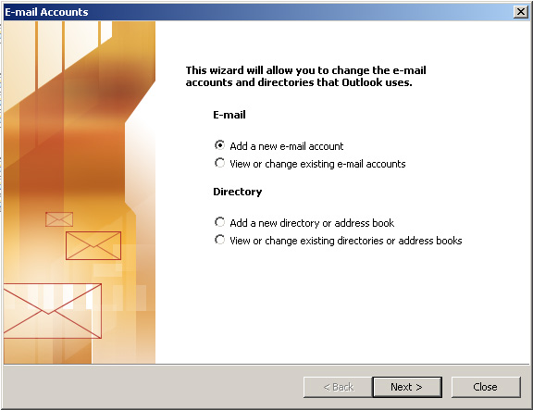

- Click next

- Then on the next pop-up window, you want to select ‘POP3’

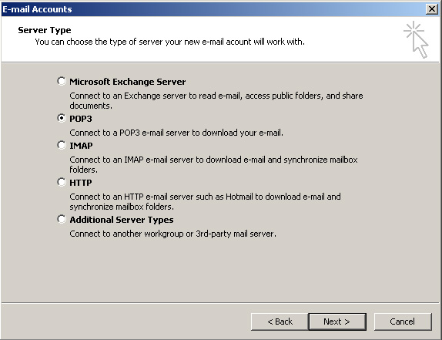
- Click next
- Under Your Name – put in the name that you want to show up when you email someone
- Under E-mail Address – put in your email address
- Under Incoming Mail Server – put in ‘pop.yourdomain.com’
- Under Outgoing Mail Server – put in ‘smtp.yourdomain.com’
- Under Username – put in username
- Under Password – put in password
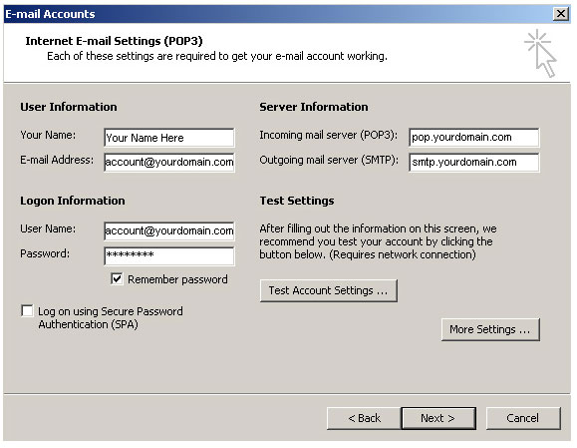
- Click on the ‘More Settings’ button
- Click on the Outgoing Server tab
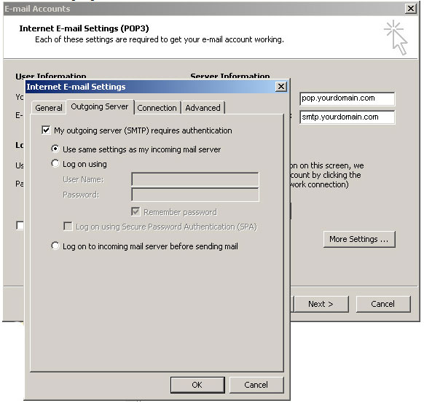
- Check the box that says ‘My outgoing server requires authentication’
- Click OK
- Click Next
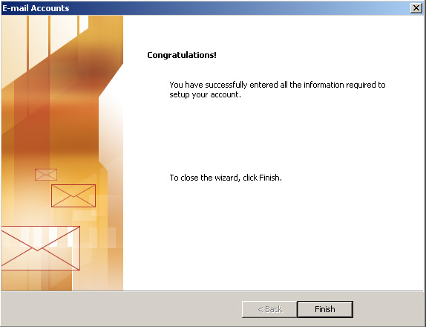
- Click Finish

