Outlook Express Email Setup

- open outlook express
- go to ‘tools’
- go to ‘accounts’

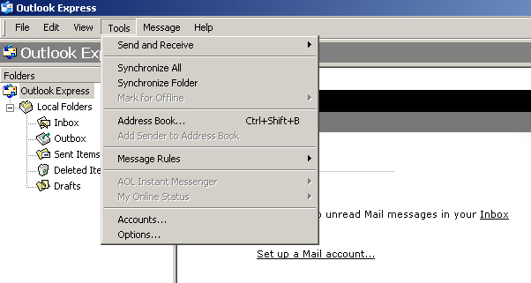

- click on Add
- click on mail

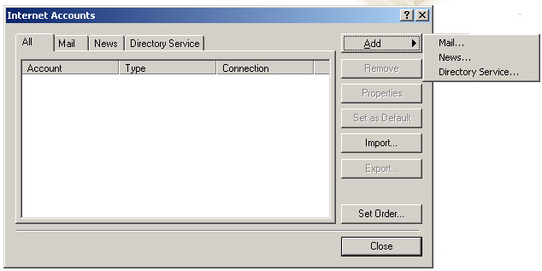

- enter your name in Name field
- click Next

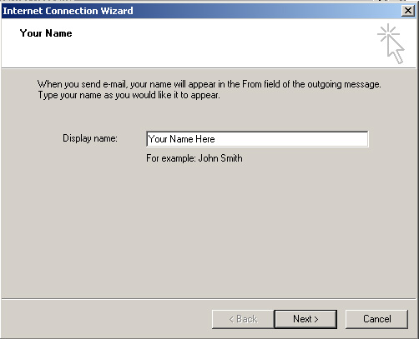

- enter your email address
- click Next
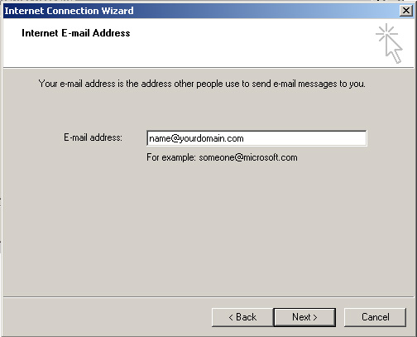

- select pop3 as the the incoming server type
- insert pop.yourdomain.com in the incoming mail box
- insert smtp.yourdomain.com in the outgoing mail box
- click Next

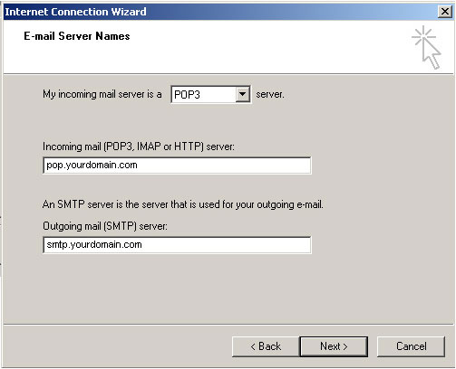

- fill in your user name (be sure to include the @yourdomain.com)
- and your password
- click Next

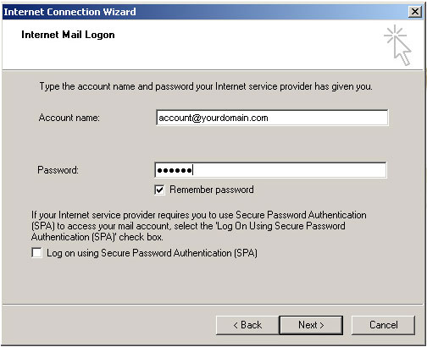

- click Finish

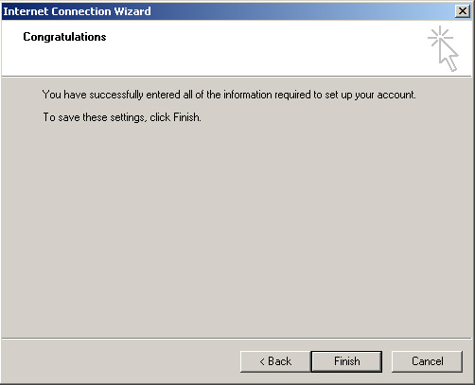

- Go to internet accounts
- Double click the account you just set up

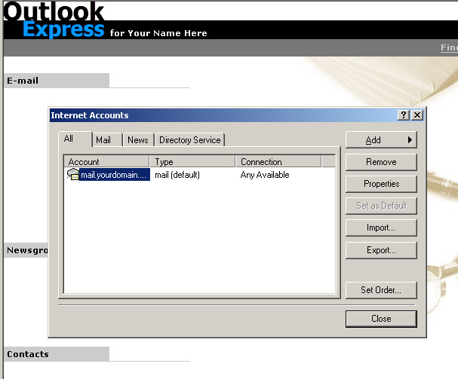

- go to the server tab
- check the box that says my server requires authentication
- click apply

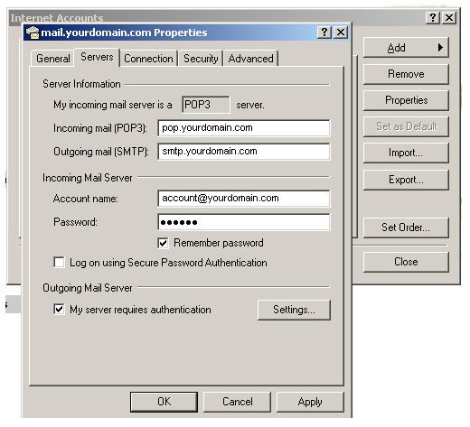

- check the Use same settings as my incoming mail server
- click OK

